**Settings menu** for your custom module.

**Step 1: Create a Settings Model**

You need to **inherit** res.config.settings and define fields with config_parameter for persistence.

📂 models\res_config_settings.py

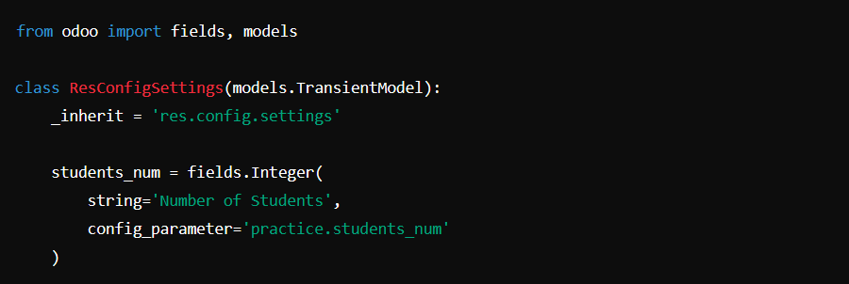

**Step 2: Create a Settings View**

Now, define the XML file to add a field to the settings page.

📂 views\res_config_settings_views.xml

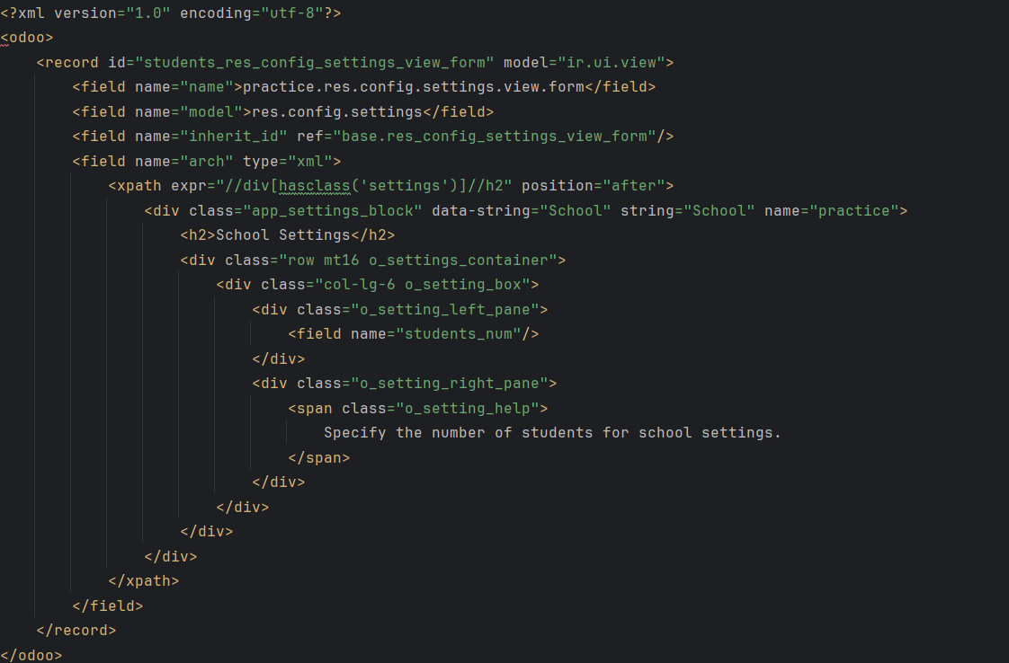

**Step 3: Define the Action (res_config_settings_views.xml)**

We need an **action** to open the settings form.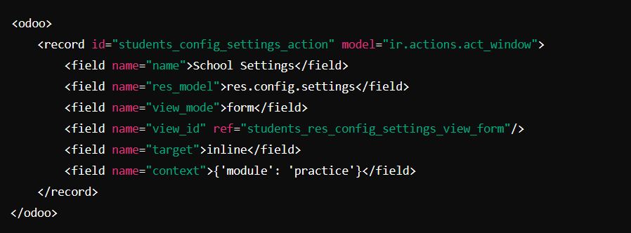

**Step 4: Create the Settings Menu (res_config_settings_views.xml)**

Now, add the **menu item** under your custom module.

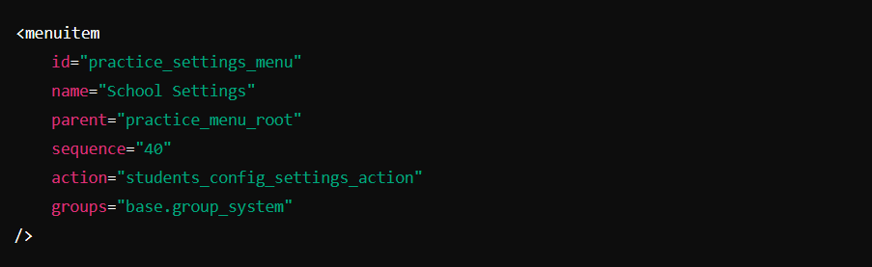

**Step 5: Add XML and Python Files to Manifest**

Make sure your __manifest__.py includes the new files.

📂__manifest__.py

